**EXPERIMENT-12**

**Title: 12. To understand the concepts of Trigger.**

**Objective:** Students will master the application of triggers for database automation. Theory:.

**Theory:**   
  
SQL triggers are powerful tools in database management, automating tasks based on INSERT, UPDATE, or DELETE events. They enforce data integrity by executing predefined actions and enable auditing for tracking changes. With a defined syntax, triggers fire before or after specified events on specific tables, offering a customizable and efficient approach to database management. Triggers facilitate complex logic and enable developers to implement business rules, ensuring consistency and reliability in database operations. This robust functionality enhances the overall efficiency and maintainability of database systems.

**Code:**

CREATE [OR REPLACE] TRIGGER trigger_name

{BEFORE | AFTER | INSTEAD OF} {INSERT | UPDATE | DELETE}

ON table_name

[REFERENCING OLD AS old NEW AS new]

[FOR EACH ROW]

WHEN (condition)

BEGIN

-- Trigger body (SQL statements)

END;

/

**CUSTOMER Table:**

|  |  |  |  |  |
| --- | --- | --- | --- | --- |
| ID | NAME | AGE | ADDRESS | SALARY |
| 1 | Ramesh | 32 | Ahmedabad | 2000.00 |
| 2 | Khilan | 25 | Delhi | 1500.00 |
| 3 | Kaushik | 23 | Kota | 2000.00 |
| 4 | Chaitali | 25 | Mumbai | 6500.00 |
| 5 | Hardik | 27 | Bhopal | 8500.00 |
| 6 | Komal | 22 | MP | 4500.00 |

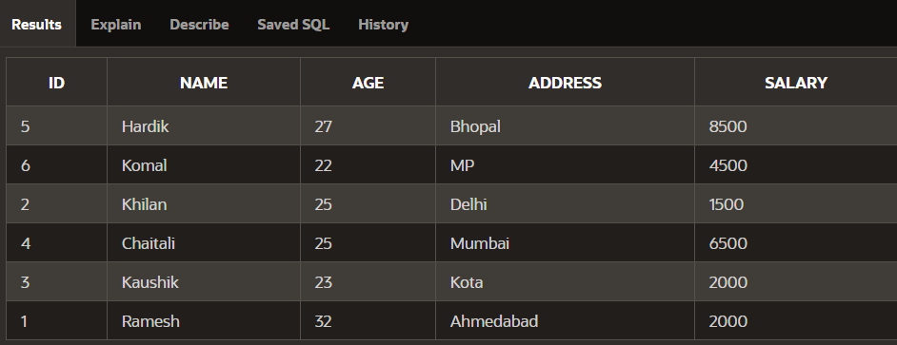

1. Create a row level trigger for the customers table that would fire for INSERT or UPDATE or DELETE operations performed on the CUSTOMERS table. This trigger will display the salary difference between the old values and new values.

